2021 RACEBOARD AUSTRALIAN CHAMPIONSHIPS
16 – 18 April 2021

SAILING INSTRUCTIONS

Organising Authority
SARATOGA SAILING CLUB Inc,
in conjunction with WINDSURFING NSW

[DP] denotes a rule for which the penalty is at the discretion of the Protest Committee and may be less than disqualification.
[NP] denotes that a breach of this rule will not be grounds for a protest by a board.
[SP] denotes a rule for which a standard penalty may be applied by the Race Committee without a hearing.

RULES
  - The Regatta will be governed by the current Racing Rules of Sailing.
  - RRS Appendix B: the Windsurfing Competition Rules (WCR) shall apply.
  - Class Championship Rules shall apply.
  - Class Rules of the International Raceboard Association will apply.
  - No National Prescriptions will apply. The Australia Sailing 2017-2020 Special Regulations Part 2 for Off the Beach Boats will apply.
  - The SIs take precedence if there is any conflict between the Notice of Race and the Sailing Instructions (SIs). This changes WCR 63.7.
  - If there is a conflict between languages the English text will take precedence.

NOTICES TO COMPETITORS
Notices to competitors will be posted on the Official Notice Board located in the Club.

CHANGES TO SAILING INSTRUCTIONS
  - Any change to the Sailing Instructions will be posted before 09:00 on the day it will take effect, except that any change to the Schedule of Races will be posted by 18:00 on the day before it will take effect.

SIGNALS MADE ASHORE
  - Signals made ashore will be displayed on the Flagpole at the Club
  - When Flag AP is displayed ashore, ‘1 minute’ is replaced with ‘not less than 30 minutes’ in the race signal AP. This changes WCR Race Signals AP.

SCHEDULE
The Championship Schedule is as per the following:

DATE | EVENT | TIME/FIRST WARNING SIGNAL
Friday 16 April 2021 | Registration | 0830 - 1000
 | Competitors’ Briefing | 1000 - 1030
 | Raceboard: up to 4 Races | 1130
 | Welcome Night Event*–Davistown RSL Bistro  *Pay as you eat, not included in Race fees. | 1900
Saturday 17 April 2021 | Raceboard: up to 4 Races | 1100
 | Function at Club | 1830
 | Raceboard: up to 4 Races | 1100
Sunday 18 April 2021 | Presentation at the Club | 1700

  - On the last day of the Regatta, no warning signal will be made after 15:00.
  - No more than 4 races per day shall be sailed in a maximum 12 race series. No more than 3 races per day shall be sailed in non-planing or marginal (for majority of fleet) planing conditions.
  - To alert boards that a race or sequence of races will shortly begin, an Orange Flag will be displayed (with one sound) at least 5 minutes before a Warning Signal is displayed.

CLASS FLAG
  - The RACEBOARD Class - Red “R”, (International Raceboard class insignia), on a white background.
.

RACING AREA
  - All races will be conducted Brisbane Waters, Gosford. The racing area is shown in Appendix A.
  - The racing area is defined as an area extending 75m beyond the course including the starting line, the finishing line and their extensions, in which a board would normally sail while racing.

COURSES
  - The diagrams in Appendix B show the courses, the order in which marks are to be passed and the side on which each mark is to be left.
  - The 7.8m2 Sail division fleet and the Sprint fleet will start with the RACEBOARD Class.
  - The Race Committee Signal Boat will display the course to be sailed no later than the Warning Signal for the Class.
  - Courses will not be shortened; this changes WCR 32.
  - Legs of the course will not be changed after the preparatory signal; this changes WCR 33.

MARKS
  - The starting marks, finishing marks and marks of the course will be as described on the course illustration in Appendix B.

THE START
  - Races will be started using WCR 26.
  - The starting line will be between a staff displaying an orange flag on the RC Signal Boat at the starboard end and the course side of the port-end starting mark.
  - A board starting later than 4 minutes after the starting signal will be scored Did Not Start (DNS) without a hearing. This changes WCR A4 and A5.
  - [DP] Boards whose Warning Signal has not been made shall avoid the starting area during the starting sequence for other Classes.

THE FINISH
  - The finishing line will be between a staff displaying a blue flag on the RC Signal Boat and the course side of the port end finishing mark.

PENALTY SYSTEM
  - [DP] [NP] Boards retiring from racing after finishing shall complete a Retirement Declaration Form at the Race Office before the end of protest time limit.
  - [DP] [NP] Boards taking a voluntary penalty shall complete the Penalty Acknowledgement Form at the Race Office before the end of protest time limit.

TIME LIMITS, TARGET TIMES AND REST PERIODS

  - The time limits and target times are as per below:
CLASS | TIME LIMIT | MARK 1 TIME LIMIT | TARGET TIME | FINISH WINDOW
RACEBOARDS | 45 minutes | 15 minutes | 25 - 30 minutes | 20 minutes

  - A race shall be abandoned if either of the time limits (above) is exceeded.
  - Boards failing to finish within the finish window after the first board sails the course and finishes, will be scored Did Not Finish (DNF) without a hearing. This changes WCR 35, A4 and A5. The closure of the finish window for the RACEBOARD Class will apply to the 7.8m2 sail and Sprint Fleets sailing a shorter course. A maximum of 3 races may be sailed back to back.
  - Rest period back-to-back races: The Warning Signal for a subsequent race will be made as soon as practicable, except that the minimum interval between the closing of the finishing line and the new Warning Signal for that Class will be 5 minutes.
  - Rest period ashore: At the completion of a series of back-to-back races, there shall be a rest period of 45 minutes ashore for the last finisher in the last race before the Warning Signal for further races.

PROTESTS AND REQUESTS FOR REDRESS
  - Protest forms are available at the Race Office. Protests and requests for redress shall be delivered to the Race Office within the appropriate time limit.
  - The Protest Time Limit is 60 minutes after the last board has finished the last race of the day or the Race Committee signals ‘no more racing today’, whichever is later.
  - Notices will be posted no later than 30 minutes after the protest time limit to inform competitors of hearings in which they are parties or named as witnesses. Parties will be advised of the location for the Protest Room.
  - Breaches of WCR 78 and rules in the Sailing Instructions marked [NP] will not be grounds for a protest by a board. This changes WCR 60.1(a). Penalties for breaches marked [DP] are at the discretion of the Protest Committee may be less than disqualification if they so decide.
  - On the last day of the regatta, a request for reopening a hearing shall be delivered:
a) within the protest time limit if the party requesting reopening was informed of the decision on the previous day;
b) no later than 30 minutes after the party requesting reopening was informed of the decision on that day. This changes WCR 66.
  - On the last scheduled day of racing a request for redress based on the Protest Committee decision shall be delivered no later than 30 minutes after the decision was posted. This changes WCR 62.2.

SCORING
  - Three (3) races are required to be completed to validate a Championship.
  - Scoring will be according to the WCR Appendix B8 except as noted in 15.3 below.
  - Overall Scores will be published for the three fleets, viz. RACEBOARDS, 7.8 m2 sail Division, Sprint Raceboard Division.
  - The finishing positions for all age and weight divisions applicable to each Class will be determined by their respective scoring position in the relevant fleet.
  - To request correction of an alleged error in the posted races or series results, a board shall complete a scoring enquiry form available at the Race Office which shall be lodged before 11:00 the following day and before the protest time limit on the last day of the Championship.

SAFETY REGULATIONS
  - Sign ON and sign OFF sheets will be provided by the Race Committee at the Race Office. Competitors intending to race shall personally sign ON at the beginning of each day’s racing and sign OFF at the earliest possible time after the completion of racing (but not later than the end of protest time); or within 30 minutes of being instructed to go ashore by the Race Committee.
  - [SP] Failure to sign ON will result in a two (2) point discretional penalty (DPI) for the first race sailed on the day; failure to sign OFF will result in a two (2) point discretional penalty (DPI for the last race sailed on the day. If only one race is sailed, failure to sign on and sign off will result in only one (1) DPI of two (2) points being applied. A board shall not be scored worse than a DNF score.
  - [DP] [NP] A board that retires from a race shall, if reasonably possible, notify the Race Committee before leaving the course area and shall sign OFF upon arriving ashore.
  - [DP] [NP] Competitors not leaving the shore for the day’s racing shall inform the Race Committee.
  - The buoyancy vest is mandatory any time that the competitor is offshore.

REPLACEMENT OF EQUIPMENT {DP]
  - Substitution of damaged or lost equipment will not be allowed unless approved by the Race Committee. Requests for substitution shall be made to the Race Committee at the first reasonable opportunity.

ADVERTISING
  - All advertising will be in accordance with World Sailing Regulation. Boards shall display any event advertising supplied by the OA.

COACH AND SUPPORT BOATS
  - If called upon support boats will be required to act as rescue boats.
  - Coach boats shall stay outside areas where boats are racing from the time of the preparatory signal.

TRASH
  - [DP] [NP] Trash may be placed aboard support or RC Boats. WCR 55 will apply.

PRIZES
  - Medals and or prizes will be awarded to the first three competitors of each properly constituted class.
  - The following titles shall be bestowed:

Australian Raceboard Champion (Male and Female)

  - Other awards may be made at the discretion of the Organising Authority.

RADIO COMMUNICATION
  - Except in an emergency, a boat shall neither make radio transmissions while racing nor receive radio communications not available to all boats. This restriction also applies to mobile telephones.

DISCLAIMER OF ENTRY
  - It is the competitor’s sole decision to enter this event and to start and or to continue to compete. By way of entering, competitors acknowledge and agree that participation in this event can be dangerous and accept that their participation is at their exclusive risk in every respect. In addition, by way of entering competitors shall hold harmless the Organising Authority, the Class Association and their officers, members, servants and agents and all other competitors in respect of all liability for injury to their person and or loss or damage to their property howsoever arising from their participation or intended participation in this event and acknowledge and accept that the organising authority, its officers, members, servants, agents and other competitors accept no responsibility in respect to loss of life, personal injury or loss or damage to property which may be sustained by reason of a competitor’s participation or intended participation in this event or arising for whatever reason in connection with this event.

RIGHTS TO USE NAME AND LIKENESS
  - By participating in the Championship competitors automatically grant to the Organising Authority, the Class Association and their sponsors, the right in perpetuity to make, use and show, from time to time at their discretion, any motion pictures and live, taped or filmed television and other reproductions of the athlete during the period of competition without compensation.
  - Boats may be required to carry cameras, sound equipment or positioning equipment as specified by the Organising Authority.
  - Competitors may be required for interviews and press conferences at the Championship.

INSURANCE
  - Each participating boat shall be insured with valid third-party liability insurance with a minimum cover of $10m per event or equivalent. Members of AWA through their respective state class association automatically have their coverage.

APPENDIX A
APPROXIMATE RACING AREA

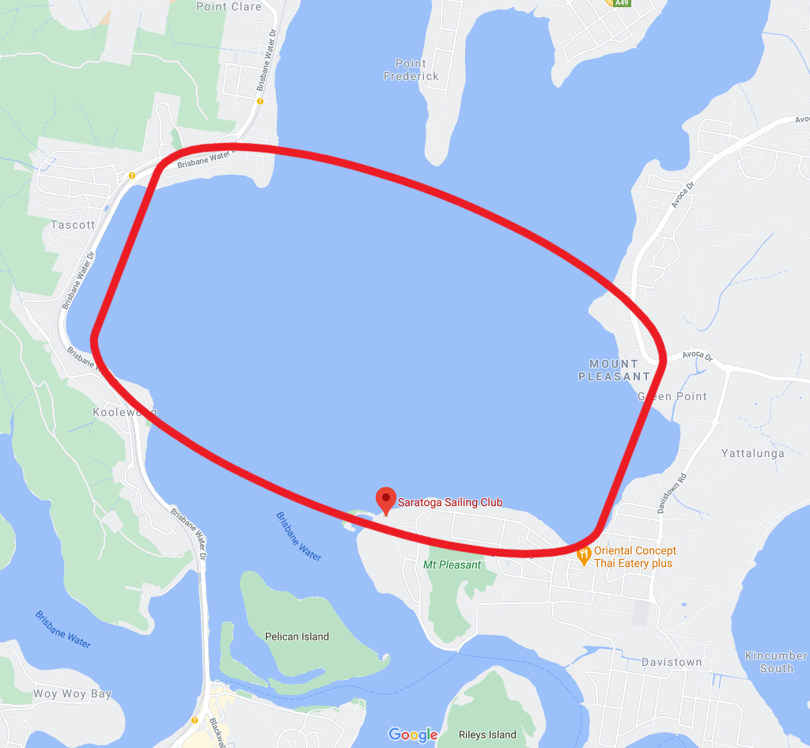

APPENDIX B
COURSES – Windward/Leeward

1

1a
Mark Rounding Order
All marks to port

Course Order
RB 1 Start, 1, Pin,
Finish

RB 2 Start, 1, Pin,
1, Pin
Finish

RB 3 Start, 1, Pin,
1, Pin,
1, Pin
Finish

Sprint 1 Start, 1a, Pin,
Finish

Sprint 2 Start, 1a, Pin,
1a, Pin
Finish

Sprint 3 Start, 1a, Pin,
1a, Pin,
1a, Pin
Finish

Finish

Start

